Wireless Local Area Network

A Wireless Local Area Network (WLAN) is needed at ASB Stadium to implement the proposed system. The research conducted is based on the information on the official ASB Stadium website (http://www.asbstadium.co.nz/) and past experiences at MATHEX events. A visit to the venue will be conducted soon to gather specifics about the venue and its infrastructure.

# Venue Layout

The main stadium, where the MATHEX event is held, has 2 separate floors (refer to figure 1). The lower floor, where the competition is held, will have the participants and judges. This area is 30 metres × 40 metres (1350 square metres). The second floor, with the seating arrangements, is where the spectators will be present. Figure 2 shows a diagram of the main gym with estimates of measurements of the second floor. Note that the section of seating area directly behind the judges isn’t utilised for MATHEX events.

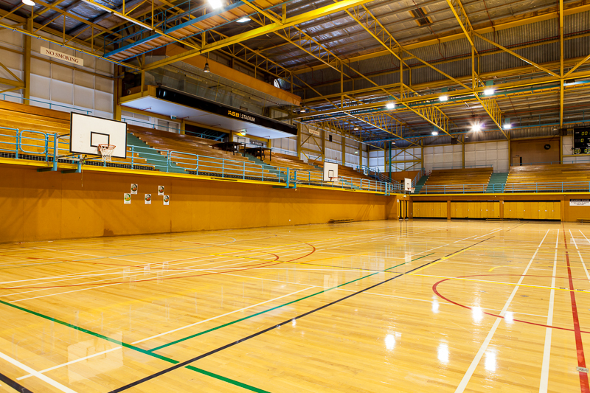

Figure 1. Main gym at ASB Stadium

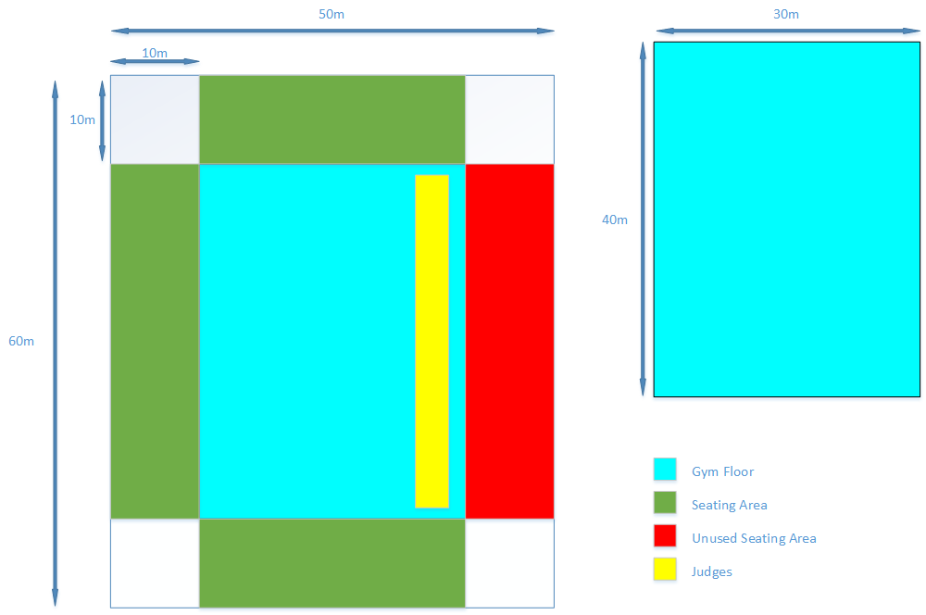

Figure 2. Diagram of main gym

# Seating arrangement

The WLAN will need to support approximately 500 users, with 100 of those users being judges. We will assume that the smaller seating sections will hold 100 spectators each and the large section will hold 200 spectators. Judges are seated on tables near the wall under the unused seating section (refer to figure 3). This is important for the distribution of access points. Access points shouldn’t be overloaded with users and there should be no access points that aren’t needed (e.g. an access point in the unused seating section).

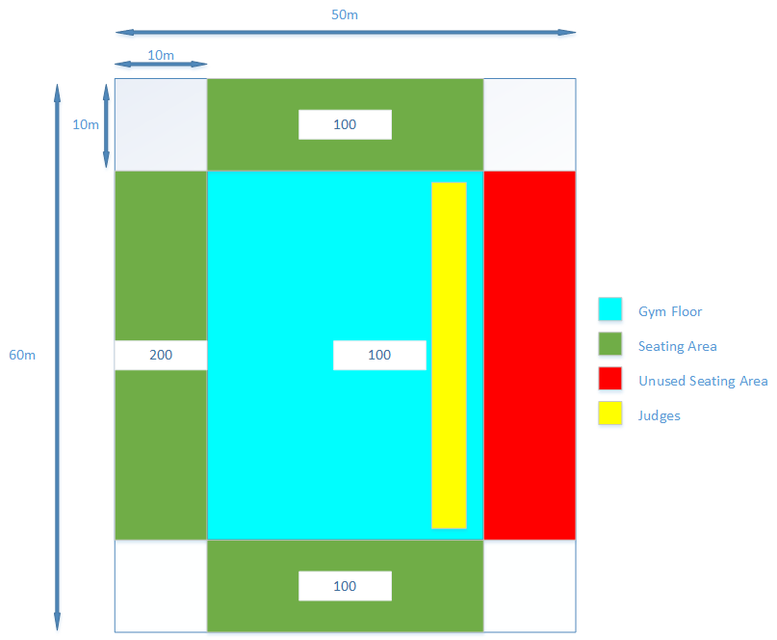

Figure 3. Diagram showing distribution of users

# Network traffic

To find the right network devices, the traffic in the network must be estimated. The client has requested a leader board view for the proposed system in which each team’s name and score is shown to spectators. We will assume that all 400 spectators will be using this leader board view and that the leader board is updated every second. It is difficult to calculate overall traffic because it depends on the implementation of the proposed system. However, we can estimate the traffic based on the size of database queries to the PostgreSQL database.

A 4-character version of the team’s name would be used to represent them in the table. The team’s score will also be needed. Note that there are 20 questions in a competition and 5 marks are awarded for each correct question so the maximum score a team can have is 100. Considering this, a SmallInt type would be the most efficient way to store this data. The time that a team finishes the competition should also be recorded in the database. A team finishes when it runs out of questions. The time would be used to order teams so if there are 2 teams with the same score, the team that finished earlier would be ranked higher. PostgreSQL has a Time data type that can be used for this.

|  |  |  |
| --- | --- | --- |
| TEAM PostgreSQL database table | | |
| Column | Type | Size |
| Code | Varchar (4) | 5 Bytes |
| Score | SmallInt | 2 Bytes |
| Time_Finished | Time | 8 Bytes |

Figure 4. Structure of TEAM table

Considering the table structure in Figure 4, we can see the size of the result of each database query would be 15 bytes. There are approximately 400 spectators at the MATHEX event who request this data every second so there is 6 Kilobytes per second (KB/s) of traffic between the spectators and the servers.

These estimations don’t account for the network traffic that the judges are responsible for because there are various operations that judges conduct when using the proposed system (e.g. answering correctly, answering incorrectly, passing a question). Also, the judges do not make transactions very frequently. Therefore, the traffic that they generate can be ignored.

# Access Points

For the WLAN, Access Points (APs) will be needed for wireless transmission of data. The Cisco Aironet 1850 series APs are suitable for the venue. They have features such as:

* 802.11ac Wave 2 wireless standards.
* 4x4 MIMO with 4 spatial streams with Single-User MIMO and Multi-User MIMO support.
* Throughput of 1.7 Gigabit per second.
* Power over Ethernet.
* External antenna model available.

MIMO, short for Multiple-Input Multiple-Output, is a wireless technology that uses multiple transmitters and receivers to transfer more data at the same time. There are 4 antennas for transmitting data and 4 antennas for receiving data. This will provide quick transfer of data between users connected to the WLAN.

The throughput of 1.7 Gigabit per second is meets our requirements and leave’s room for growth of the proposed system (if the attendance of MATHEX events increases in the future).

Power over Ethernet (PoE) allows APs to be powered through Ethernet cables. This could be particularly useful considering the venue’s infrastructure is unknown at this stage. By utilising the PoE capabilities, we would be able to place APs per ourselves without being limited by the location of power sources.

External antennas for APs allow the wireless signals to be transmitted in particular directions. This could be useful for the WLAN if APs were to be positioned at the front of each seating section (refer to figure 5). If internal antennas are used, wireless signals would be transmitted towards the participants. This isn’t an ideal use of the AP as participants aren’t allowed phones and won’t be utilising the proposed system. External antennas provide more efficient use of the AP but must be purchased separately.

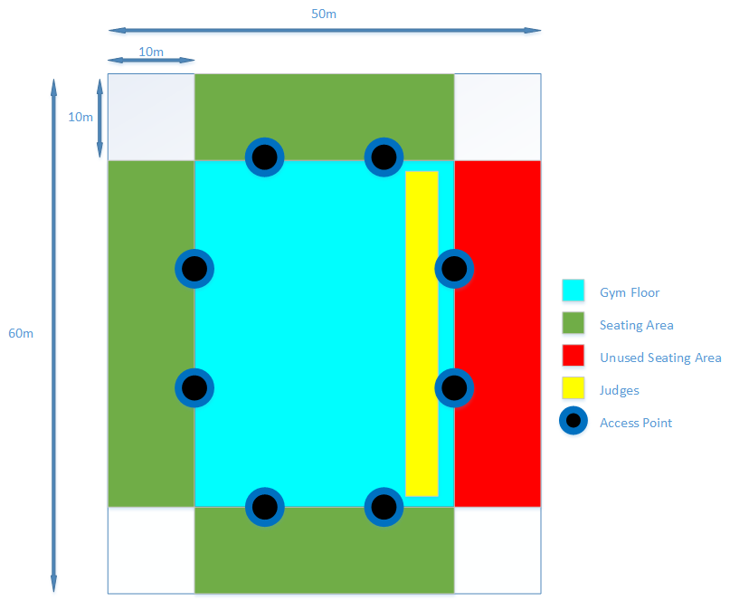

Figure 5. Diagram of AP distribution

These APs can support up to 400 clients each. However, to improve efficiency and reliability of the network, each AP should ideally support approximately 80 clients. Following this guideline, 8 APs would be needed for the network. If there are more than 500 users of the system, the 8 APs should be able to accommodate for them. In the future, if there is considerable growth in the attendance of MATHEX events, more APs could be deployed.

# Switch

For the network switch, a 16-port switch with PoE capabilities is needed to support the APs. The WS-C2960L-16PS-LL switch by Cisco would provide this functionality. It is a basic switch with 16 ports. An 8-port switch wouldn’t be ideal as if there is a need for an extra AP in the future, the switch would have to be replaced with a 16-port switch. The switch will be able to power all APs with it’s PoE capabilities.

# References:

<http://www.asbstadium.co.nz/>

<http://www.cisco.com/c/en/us/products/wireless/aironet-1850-series-access-points/index.html>

<https://www.postgresql.org/docs/9.2/static/datatype.html>

<http://www.intel.com/content/www/us/en/support/network-and-i-o/wireless-networking/000005714.html>

<http://www.cisco.com/c/en/us/products/collateral/switches/catalyst-2960-l-series-switches/datasheet-c78-737665.html>

CASIO MATHEX ENTRY FORM 2014 - <http://www.aucklandmaths.org.nz/wp-content/uploads/2012/08/Mathex-Entry-form-and-Info-to-schools.doc>

Stadium image - <http://www.asbstadium.co.nz/uploads/4/7/4/6/47460497/9258502_orig.jpg>